ECE5 Spring 2017 Lab 4 Line Following Robot Wars

PID -- following a sinusoidal road

Top two traces: S = 3, P = 0.1, I = 0, D = 0.7
Bottom traces: S = 3, P = 0.1, I = 0, D = 0.3

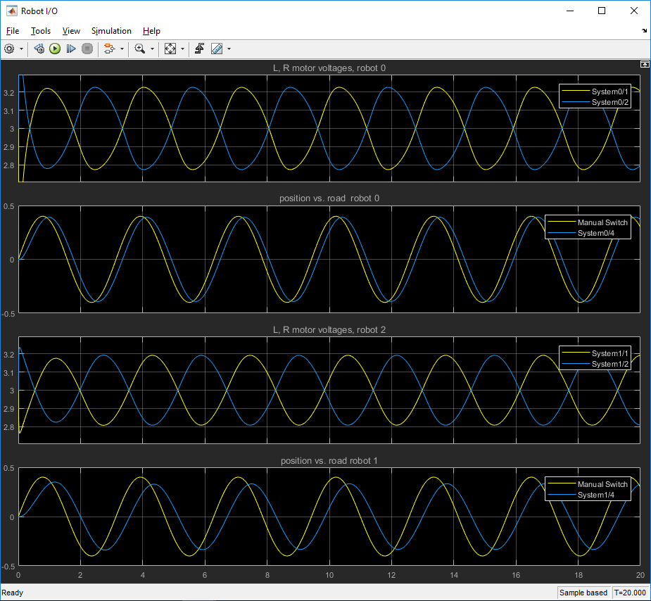

Top and third traces are applied L and R motor voltages.
Second and fourth show robot's ability to follow the road.

What is the effect of changing D? Why does this work in this manner?

Same PID, following a jog in the road

Now observe the difference between the high-D (upper) and low-D (lower) traces.

Which does a better job of tracking a sudden lateral jump in the road?

Comments regarding overdamping?

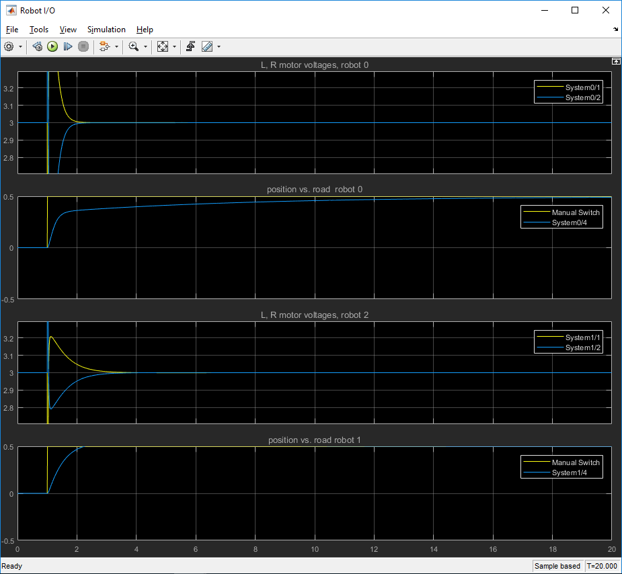
Same setup, but with a chrip (sinusoid of gradually increasing frequency) in the road

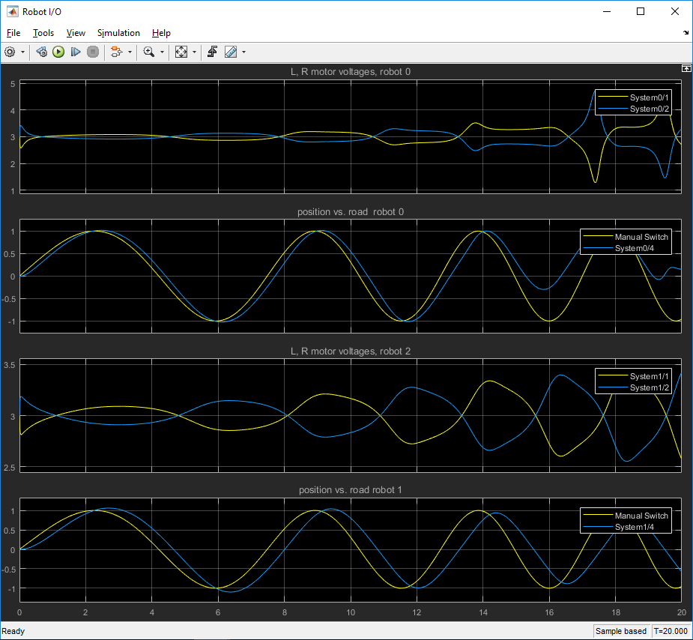

What happens at the higher spatial frequencies? What can/should we do about this?

